# Power BI project Diary

27/10/2022

Redefined project scope and updated the document

Installed the Power BI Desktop

Created a MS Planner

28/10/2022

Internal review of which systems to prioritse for the Power BI project. Initial focus is on SmartSheets and Fieldview.

Generated API Access token in SmartSheets

PowerBI Key hPcPesbCiZFfkvf9pa3BOa9OgMP70zmPkJ2ie

Initial exploration of Smartsheets connected with Power BI.

Will need to learn on how to present data etc

23/11/2022 – Power BI training with Spanishpoint technologies

End of day test data result

05/01/2022 Identified MS Training Modules for training

Source

[Browse all learning paths and modules - Training | Microsoft Learn](https://learn.microsoft.com/en-us/training/browse/?products=power-bi&roles=developer)

05/01/2022 Completed Introduction to Power BI embedded analytics

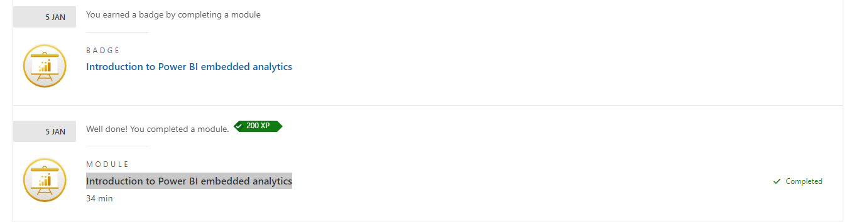

09/01/2022 – Developed Task board with sprints

Installed API Agent Postman on Laptop

Identified potential Power Query learning

[What is Power Query? - Power Query | Microsoft Learn](https://learn.microsoft.com/en-us/power-query/power-query-what-is-power-query)

[Power Query documentation - Power Query | Microsoft Learn](https://learn.microsoft.com/en-us/power-query/)

Installed postman

[Postman API Platform](https://web.postman.co/)

Requested and received API information for Viewpoint FieldView

[APIs | Viewpoint Help](https://help.viewpoint.com/en/viewpoint-field-view/field-view/api-documentation/apis)

Downloaded and installed SOAP UI For Fieldview Testing

Created API and tested general function

JSON data brought back

As per below in SOAP Ui

10/01/2023

Having issues connecting PowerBI directly to Fieldview.

Found a Python source for getting data

[samples/soap_api.py at master · kirkwilson-git/samples (github.com)](https://github.com/kirkwilson-git/samples/blob/master/SOAP%20API%20Demo/soap_api.py)

PowerBI with Python

[Run Python scripts in Power BI Desktop - Power BI | Microsoft Learn](https://learn.microsoft.com/en-gb/power-bi/connect-data/desktop-python-scripts)

Installed Python locally

[Download Python | Python.org](https://www.python.org/downloads/)

10/01/2023

At weekly meeting was instructed to review PowerApps as a solution for logging times sheets

11/01/2023

Further investigation into SOAP REST API and Power BI – couple of potential resources found that might assist with bring data to a local repository.

[How to import REST API in Power BI (Load JSON / SOAP XML) | ZappySys Blog](https://zappysys.com/blog/howto-import-json-rest-api-power-bi/#Calling_XML_SOAP_Web_Service_in_Power_BI)

[Calling SOAP API in Power BI (Read XML Web Service data) | ZappySys Blog](https://zappysys.com/blog/call-soap-api-power-bi-read-xml-web-service-data/)

Investigated into PowerApps, found a bit on timeSheets and signed up for a course with Spanish Point on the 19th of February.

[PowerApps/README.md at master · aprildunnam/PowerApps (github.com)](https://github.com/aprildunnam/PowerApps/blob/master/Timesheet/README.md)

12/01/2023

On site WIT

Setup initial repository with python sample

[ingelsten/FieldViewAPI (github.com)](https://github.com/ingelsten/FieldViewAPI)

Found further resource to unlock the API

[Unlocking your data with the Field View API | Trimble Viewpoint](https://www.viewpoint.com/en-gb/resources/webinars/unlocking-your-data-with-the-field-view-api)

13/01/2023

Minor testing with Powershell script to retrieve data

Can save to CSV

Used and installed Windows PowerShell ISE

Installed Powershell addition to Visual Studio

Investigation options of connection SOAP API to Power BI

[How to connect to a SOAP API in Power BI/ Power Query - YouTube](https://www.youtube.com/watch?v=-L6ZHnfxQ1s)

14/01/2023 (Saturday)

Re-Worked on plan and started interim report

15/01/2023 (Sunday)

Further work on interim report and plan

16/01/2023

Went to Dublin, IT induction, New WiFi – issues with VPN. Full day 14 hours

17/01/2023

Further investigation of the Fieldview API. Designed and divided up so have to potential export into lists and then do views, queries for PowerBI

Loops

Loop through text

[Foreach in File Powershell: How to Iterate the Content of a Text File (itechguides.com)](https://www.itechguides.com/foreach-in-file-powershell/#:~:text=If%20you%20have%20a%20text,the%20file%20line%20by%20line.)

Exporting to csv or txt

[How to export and append data into a CSV file using PowerShell (morgantechspace.com)](https://morgantechspace.com/2022/09/how-to-export-and-append-data-into-a-csv-file-using-powershell.html)

18/01/2023

Removal of duplication in CSV was tested and rolled out in script

[Use PowerShell to Remove Duplicate Lines from a CSV File - Scripting Blog (microsoft.com)](https://devblogs.microsoft.com/scripting/use-powershell-to-remove-duplicate-lines-from-a-csv-file/)

Barracuda Email filter implemented and tested.

Figured out pushing CSV to SharePoint online

20/01/2023

Meeting with internal supervisor – focus is now on Vehicle report.

Meeting with external supervisor – keep drivingon and mind GDPR

21/01/2023 – Resolving Null issue

22/01/2023 – First script resolved, with loop, null issue and exporting to SharePoint at the same time. Started added text for technologies.

23/01/2023 – Installed Latex for report wri tingwill probably not use

[Getting MiKTeX](https://miktex.org/download)

Started added dashboard, model in PowerBI

Need to solve autoresfresh

29/01/2023 – Moved away from Visual Studio to VS Code and setup a new GIT account. Corrected scripts. And wife read document.